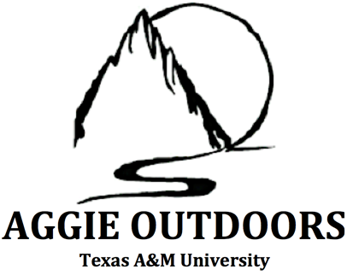
2020 Aggie Outdoors Application
DUE DATE: January 30, 2020 by 5 PM in Koldus Lobby
Email any questions to aorecruitment2020@gmail.com

Turn in your application following these instructions:
- 1 copy of the cover page (this page) with your name
- 1 copy of your application (two pages for answers) stapled with your cover page.
- All components should be delivered in a manilla envelope with you name on the front.
- Note all answers must be typed on this application, any applications submitted in writing will NOT BE ACCEPTED

The mission of Aggie Outdoors (AO) is to unite those who share aspirations of acquiring knowledge and experience of the outdoors, as well as those who hold common interests in improving their social skills, increasing their capacity for service, and building their leadership skills.
Aggie Outdoors is a non-profit coed social and service organization that takes part in various social activities, including but not limited to, camping and backpacking trips, weekend and day trips to various state parks and/or other outdoor recreational venues, and in-town social events. Aggie Outdoors will also be involved with various service events. These events include, but are not limited to, on-campus outreach, local community service projects, and recurring philanthropy events.
Standard Information:
Full Name
Email
Phone Number
Major
Month and Year of Graduation
GPA > 2.0 (Yes/No)
T-Shirt Size
What song should we listen to as we read your app?

Current Information:

- Have you applied to Aggie Outdoors before?

Yes No

- Would you be available to come to the new member retreat on February 8?

Yes No

- What other commitments are you involved/plan to be in this semester? (work, organizations). Are you applying to any other organizations this semester? Please note that this will not hurt your application in any way.

- How did you hear about Aggie Outdoors? (Circle one)

Bannering/Pie Boards MSC Open House Referred by friend

If other explain: _________________________________________________________

General Questions:

- What do you hope to personally gain from your involvement as a member of Aggie Outdoors, and what can you bring to AO?

- If you had the opportunity to master one skill, what would it be and why?

Creative Questions:

- Describe your ideal outdoor experience.

- If you were to become internet famous, what would it be for?

- Using a separate sheet of 8.5” x 11” paper, express yourself in any way you’d like. If you include any pictures of yourself, please cover your face to remain anonymous.

**Please submit the cover page along with your written responses (two pages MAX) in a standard manilla envelope in the Koldus Lobby by 5 pm on January 25th.

